African Populations and the Evolution of Human Mitochondrial DNA
Linda Vigilant, Mark Stonking, Henry Harpending, Kristen Hawkes
Science, New Series Vol 253, Issue 5027,(Sep,27 1991) 1503~1507
Abstract
Where are we come form? What can be used to measure our stem?
An African origin for human mtDNA is supported by three statical tests.
- Introduction to mtDNA
Why not use DNA sequence?
Characteristics of mtDNA
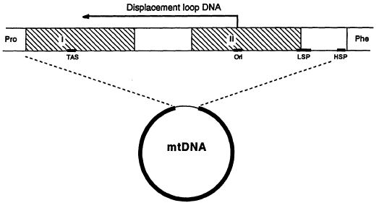
- Sequences and Geographic Specificity
Analysis of 189 individuals: 121 native Africans and 68 additional individuals. Each unique sequence is termed an mtDNA type.
There is no sharing of mtDNA types among people from different populations. It displays strong geographic specificity.
Only one exception
→ Yoruban and an African American
→ African Americans stem mainly from West Africa
- Tree Analysis
- Midpoint method : assume the rate of evolution all the same
- Outgroup method : uses a sequence (African ape) to place human mtDNA ancestor on the network..
→ minimizes the total number of mutations in the tree.
→ high-resolution restriction map not available → chimpanzee
Step 1 : Eliminate uninformative nucleotide
Step 2 : 119 informative sites were used to determine branching order
Step 3 : Uninformative nucleotide position
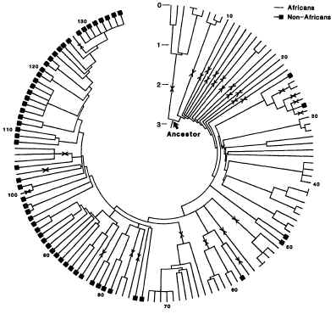
- Access the significance
- Winning site method : proof by contraction
→ African : Alternative = 13 : 2
2. Geographic method : apply the hypergeometric distribution
135 types : 31 exclusively African & 24 exclusively non-African
n = 14, x = 31, y = 24
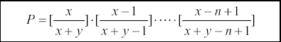

There is a 0.006% probability that the observed distribution of geographic states could occur by chance
- mtDNA sequence differences: African origin is also suggested by
the finding that mtDNA sequence differences are bigger among Africans than among Asians or Europeans.

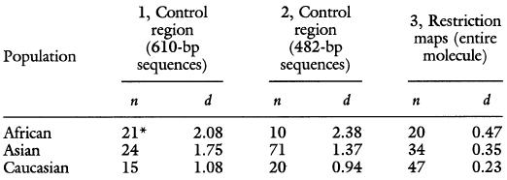
- Rate of Evolution
Average sequence difference between human and chimpanzee is 15%. But some nucleotide positions may have mutated more than once.
Transitions : mutation of a pyrimidine base.
Transversions : mutation of a purine base.
Transitions : transversion = 15 : 1 (Set 1 transversion to 15 transitions)
We can adjust the amount of sequence difference to 69.2%. The rate of divergence is roughly 11.5% to 17.3% per million years. → 4~6million years human-chimpanzee mtDNA divergence.
- Modern Human Origins
All mtDNAs found in contemporary human populations stem from a single ancestral mtDNA, so does fossil record.
- Conclusion
Created by: Chia-Ling Sun
Date : December 13,2002

